Cheque Legal and Courtesy detection and

Courtesy amount Recognition

Part A

Courtesy and Legal Amount Localization on Bank Cheques

summary
Part A delivers a production-style localization pipeline that outputs exactly two bounding boxes per cheque in original image coordinates:
- Courtesy amount (digits region)
- Legal amount (written words region)
The detector runs on full cheque images, generates one top-scoring box per class, and produces evaluation metrics aligned with the term project rubric: mean IoU and accuracy at IoU ≥ 0.50, 0.75, 0.90, reported separately for courtesy and legal plus overall. The same pipeline exports a clean courtesy crop per cheque to feed Part B.

Objective and outputs

Objective
For every cheque image, produce two regions of interest:
- Courtesy amount box (handwritten digits)
- Legal amount box (amount written in words)
The system must:
- Output boxes in the original cheque coordinate space
- Provide metrics that match the assignment’s IoU-based grading

Outputs produced

The Part A run generates:
- A prediction structure (top box per class per cheque)
- A final evaluation report: json
- A courtesy crops folder for Part B
- A mapping CSV that ties each original image to its crop
These artifacts make the workflow easy to audit and simple to reuse in a fresh environment.

Detector model, training setup, and preprocessing

Model choice
The localization engine is a Cascade R-CNN detector with a ResNet-50 backbone and Feature Pyramid Network (FPN) implemented in Detectron2.
Why this model fits the task:
- Two-stage detection (RPN then ROI heads) handles small regions like courtesy digits better than single-stage baselines when the background is cluttered.
- FPN provides multi-scale features, which matters because courtesy and legal regions occupy different spatial scales.
- Cascade refinement improves box tightness. It runs multiple ROI box heads sequentially. Each stage trains with a higher IoU target, so later stages learn to correct earlier localization errors.
Implementation details used in inference:
- Detectron2 config: Misc/cascade_mask_rcnn_R_50_FPN_3x.yaml
- NUM_CLASSES = 2
- MASK_ON = False (the task is box localization, not segmentation)
- Score threshold during inference: SCORE_THRESH_TEST = 0.30 (top boxes per class are still selected after this)
- Outputs per image are reduced to one box per predicted class (highest score).

Training setup and what “ResNet-50” means here
ResNet-50 is the CNN backbone that converts the cheque image into feature maps. In practice:
- The backbone starts from weights pretrained on large-scale natural image data. That gives stable, low-level edge and texture filters from day one.
- Fine-tuning adapts those features to cheque structure, printed fields, and handwriting noise.
The detector is then trained on your cheque dataset to learn:
- Region proposals that cover the two target areas
- Class assignment (two classes)
- Final bounding box regression for tight localization
The “3x” schedule in the config name represents a longer training schedule compared to 1x. It typically increases iterations and improves convergence when the dataset is not huge and the localization must be precise.

Preprocessing strategy
Part A uses conservative preprocessing. The goal is to improve consistency and contrast without destroying delicate strokes that affect both detection and crop quality.
There are two places preprocessing can appear:
- Training-time preprocessing: applied to images that feed the detector during training.
- Inference-time preprocessing: applied right before running the predictor.
For this submission, the detector uses the same preprocessing recipe for training and inference on the professor test set. This keeps the input distribution consistent and improves localization stability on faint handwriting and uneven illumination.
The preprocessing philosophy is still important because it guided the overall pipeline, and the same ideas are reused later for Part B OCR crops.

What we avoid
We avoid operations that can erase critical cues:
- Aggressive binarization
- Heavy smoothing that removes thin pen strokes
- Strong morphological operations that merge separated strokes

What we apply (safe enhancements)
The pipeline applies light, cheque-friendly enhancements that preserve thin strokes:
- Grayscale normalization: stabilize intensity statistics across scans.
- CLAHE: increase local contrast in washed regions and shadowed areas.
- Light denoising: small-kernel median or mild bilateral filtering to reduce speckle while preserving edges.
These operations run with low strength settings. They improve legibility and feature clarity, and they keep the handwriting texture that the detector relies on.

Evaluation protocol

Metrics reported
For the professor test set (N = 600), the pipeline reports:
- Mean IoU (overall, courtesy, legal)
- Accuracy at IoU thresholds (0.50, 0.75, 0.90)
  - overall
  - courtesy
  - legal
Key metrics:
- Mean IoU overall: 68.16%
- Mean IoU courtesy: 58.74%
- Mean IoU legal: 77.58%
Accuracy at IoU ≥ 0.50:
- Overall: 84.83%
- Courtesy: 71.50%
- Legal: 98.17%
Accuracy at IoU ≥ 0.75:
- Overall: 39.08%
- Courtesy: 14.83%
- Legal: 63.33%
Accuracy at IoU ≥ 0.90:
- Overall: 06.17%
- Courtesy: 02.00%
- Legal: 10.33%

Interpretation
Legal localization performs strongly across strict thresholds. The legal region has a clear structure and consistent placement across cheques, which supports tight regression. Courtesy localization stays reliable at IoU 0.50 and drops at stricter thresholds for two concrete reasons:
- Smaller target region: The courtesy digits occupy a smaller area, so small coordinate shifts result in a rapid reduction of IoU.
- Annotation scope mismatch in the professor test set: the professor GT for courtesy is often drawn around the full courtesy field box area, while the project objective focuses on the amount handwriting region. The detector localizes the handwriting region tightly because that is the useful crop for OCR. When GT encloses a larger template box, IoU decreases even when the detected region is centered on the correct amount.
This behavior affects IoU at 0.75 and 0.90 the most. The courtesy crops remain correct for Part B because they cover the digit string with padding and preserve stroke detail.
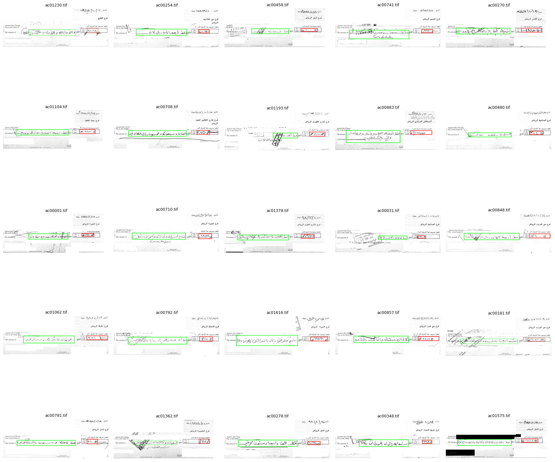
OUR ANNOTATIONS
Professors ANNOTATIONS
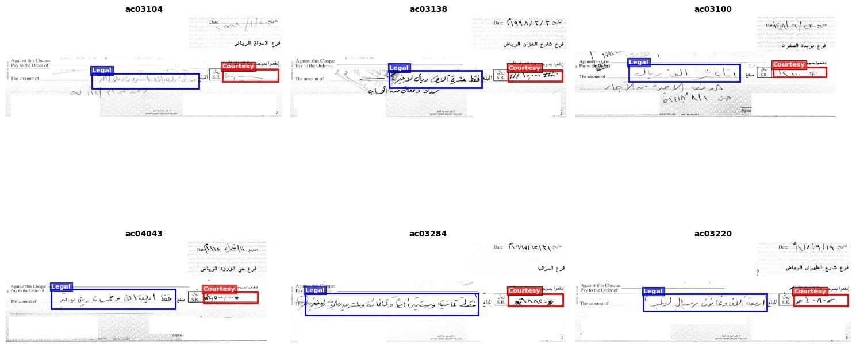
AS we can see, the courtesy amount annotations are different, so the results came out odd for the Courtesy Amount
The results for our test set are (The split from the original data set) given below,
=== Validation Metrics (IoU based) ===
Images: 177
Mean IoU overall: 0.8021
Mean IoU Courtesy: 0.8018
Mean IoU Legal: 0.8025

IoU >= 0.50 overall: 0.9746 courtesy: 0.9661 legal: 0.9831
IoU >= 0.75 overall: 0.7373 courtesy: 0.7571 legal: 0.7175
IoU >= 0.90 overall: 0.1808 courtesy: 0.1864 legal: 0.1751
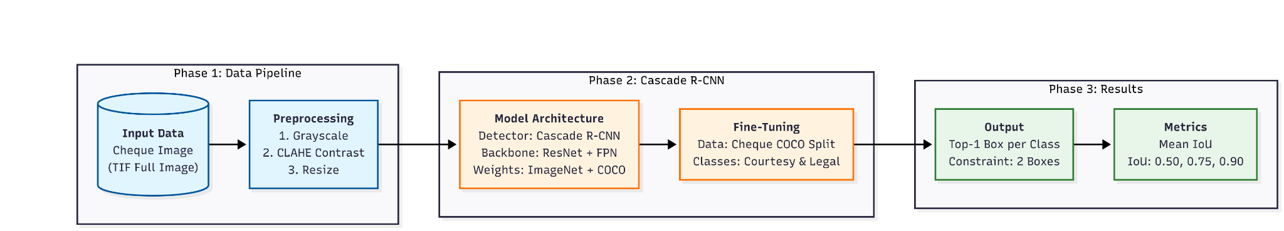

Fig.1. Part A - Architecture

Part B: Courtesy Amount Recognition

Objective
Part B focuses on recognizing the cheque courtesy amount as a digit sequence from cropped image regions. The system receives courtesy amount crops produced by Part A and outputs a digit-only string for each cheque image. The output format matches the project grading rules.

Data and Ground Truth Format

Inputs to Part B
· Input images are courtesy amount crops, one crop per cheque.
· Crops come from the Part A detector and are saved using the cheque stem naming scheme (example: ac03008.png).

3. System Overview
The Part B system has three stages.

3.1 Preprocessing
Preprocessing shapes the courtesy crop into a consistent, high-contrast input that matches the model’s training distribution. The crops come from Part A and often include background texture, faint pen strokes, and sometimes box frame lines. The preprocessing pipeline focuses on three goals: stabilize illumination, suppress non-digit structures, and strengthen ink strokes.
Input: a single courtesy crop image.
Step 1: Grayscale conversion - Read the crop in grayscale. - Keep all information in one channel. This aligns with the model input and reduces compute.
Step 2: Border cleanup (frame line suppression) - Whiten a thin margin around the crop (a few pixels on each side). - This removes many cheque box frame strokes that sit on the crop boundary. - The operation is stable and fast because it touches only the border region.
Step 3: Optional long line removal (straight line filter as seen with the new test images) - Build a simple ink mask by thresholding (dark pixels represent ink candidates). - Extract long horizontal and vertical structures using morphological opening with elongated kernels. - Remove only pixels that belong to these long straight lines. - Apply a safety fallback based on ink pixel count. If removal erases too much ink, the pipeline reverts to the border-only version for that sample.
Step 4: Enhancement (ENH v3) ENH v3 produces the input style that worked best during Part B training.
· Median denoise removes salt and pepper noise while preserving edges.
· Background estimation uses a morphological open on the inverted image to estimate slow illumination variation.
· Background subtraction isolates handwriting by subtracting the background estimate from the inverted image.
· Normalization scales the ink response to a stable 0 to 255 range.
· CLAHE increases local contrast and recovers faint strokes.
· Ink boost multiplies the inverted ink intensity by a tuned factor (example: 1.30) to strengthen thin writing.
· Light sharpening improves stroke boundaries after denoise and contrast steps.
This pipeline keeps the background bright and brings the pen strokes closer to a consistent darkness level across cheques.
Step 5: Resize to a fixed height - Resize each crop to a fixed height of 48 pixels. - Preserve aspect ratio to keep character shapes natural. - Fixed height stabilizes the CNN receptive field and produces predictable feature map shapes.
Step 6: Normalize and batch pad - Convert pixel range from 0 to 255 into 0 to 1 float values. - Pad width in the batch collate step to the maximum width of the batch. - Preserve the original width per sample so the model can handle variable-length sequences.
What the model sees. The final tensor has shape (B, 1, H, Wpad) with H = 48. The network reads along the width direction and treats the width positions as time steps.
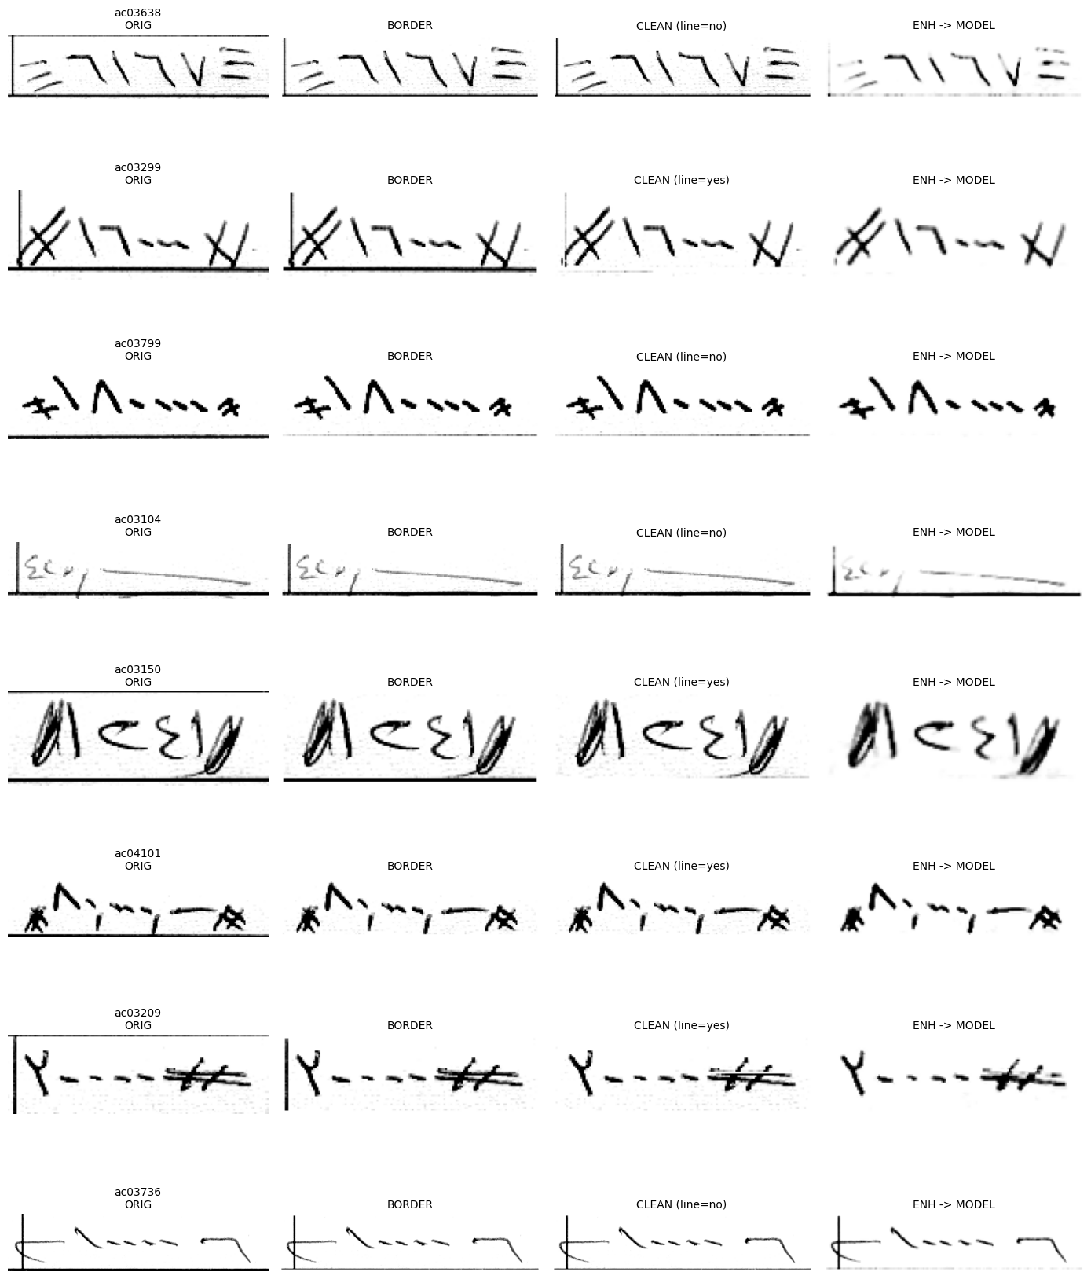

Model Architecture
We use a CRNN with CTC for sequence OCR. The design matches the problem structure. The courtesy amount is a horizontal sequence of digits with variable length. The crop width changes from cheque to cheque. CTC supports alignment without requiring character-level bounding boxes.

CNN Encoder (feature extractor)
The encoder is a residual CNN that converts the preprocessed image into a compact feature map.
· Input: (1, 48, W)
· Residual blocks improve gradient flow and stabilize training.
· Pooling reduces height aggressively and reduces width gradually.
The pooling strategy is important: - Early pooling reduces both height and width. - Later pooling reduces height while preserving width. This keeps enough time steps for long sequences.
The output feature map has shape (C, Hf, Wf) where Wf is proportional to the input width. Wf becomes the number of time steps used by the sequence model.

Feature map to sequence
The model converts the CNN feature map into a time series.
· Permute the feature map so width becomes the sequence dimension.
· Flatten the channel and reduce height dimensions into a feature vector per time step.
This produces a sequence tensor of shape (B, T, F) where: - T = Wf time steps - F = C * Hf feature dimension

BiLSTM sequence modeling
A BiLSTM model has dependencies across time steps.
· Bidirectional recurrence uses left context and right context.
· This captures writing continuity and improves digit disambiguation.
· Two layers provide a strong capacity for sequence patterns.
The output remains (B, T, 2H) where H is the hidden size.

CTC classification head
A linear layer maps each time step to character logits.
· Output logits per time step cover the full charset plus the CTC blank.
· Log softmax produces log probabilities needed by CTC.
The final tensor for CTC has shape (T, B, C).

Training target and charset
We trained with Option A: - Targets use raw_text_norm that includes digits and symbols. - This gives the model exposure to real annotation patterns such as hashes and delimiters.
CTC uses a dedicated blank class and learns alignments implicitly. The model outputs a sequence that preserves character order.

Decoding and Postprocessing
This stage converts per time step probabilities into the final digits only prediction.

Greedy CTC decoding
Greedy decoding follows the standard CTC rule: 1. Select the most likely class at each time step. 2. Collapse consecutive repeats. 3. Remove the blank label.
This produces a raw predicted string in the training charset.

Digits only postprocess
Project grading requires digits only output.
· Remove all characters except 0 to 9.
· Keep digit order.
· Return an empty string when no digit remains.
This postprocess standardizes output formatting and makes evaluation consistent.

Evaluation Metrics
All reported metrics are computed on digit-only strings.

Edit distance counts
For each sample, we compute the Levenshtein edit distance between predicted digits and GT digits and accumulate: - I: insertions (extra predicted digits) - D: deletions (missing predicted digits) - S: substitutions (wrong digit)

Digit accuracy
Digit accuracy aggregates per digit errors:
Digit accuracy = 1 - (I + D + S) / N_GT_digits

Exact match
Exact match measures per cheque correctness:
Exact match = (# samples with zero edits) / (# samples)

Error buckets
We also report the percentage of samples with: - 0 errors - 1 error - 2+ errors

Results on Professor Test Set
We matched 598 professor-labeled samples and evaluated all checkpoints with the metrics above.
Checkpoint | Match | Digit Acc | Exact Match | I | D | S | 0 err | 1 err | 2+ err
v1_best_digitacc | 598 | 0.9588 | 0.8495 | 33 | 48 | 26 | 0.8495 | 0.1271 | 0.0234
v1_best_exact | 598 | 0.9588 | 0.8495 | 33 | 48 | 26 | 0.8495 | 0.1271 | 0.0234
v1_last | 598 | 0.9665 | 0.8779 | 26 | 42 | 19 | 0.8779 | 0.1003 | 0.0217
v2_best_digitacc | 598 | 0.9630 | 0.8679 | 31 | 44 | 21 | 0.8679 | 0.1087 | 0.0234
v2_last | 598 | 0.9496 | 0.8311 | 28 | 71 | 32 | 0.8311 | 0.1321 | 0.0368

Selected model
We selected v1_last as the final model based on the best professor GT exact match and the best digit accuracy.
Key numbers (v1_last): - Exact match: 0.8779 - Digit accuracy: 0.9665 - Most errors come from deletions (D = 42), then insertions and substitutions.

Error Analysis
The evaluation shows a strong deletion component. Deletions occur when the model misses a digit that exists in the handwriting. This pattern matches cheque writing conditions.

Typical failure modes
Faint strokes - Light pen pressure produces thin digits. - Contrast enhancement helps, but a few strokes still vanish.
Digit merging - Adjacent digits touch, especially around repeated zeros. - The visual boundary disappears, and the model outputs fewer digits.
Border and box artifacts - Some crops include horizontal and vertical frame lines. - These lines compete with digit strokes and distort the feature map. - Border whitening and long line removal reduce this interference.
Spacing variability - Writers use inconsistent spacing and separators. - The CTC model handles spacing through alignment, and postprocessing removes separators for the final output.

Observed error distribution
The best checkpoint v1_last shows: - Deletions as the dominant error type. - Insertions at a lower rate. - Substitutions as the smallest contributor.
This distribution supports a concrete improvement direction. Stronger digit preservation improves results. Border suppression and ink boost already move in that direction.
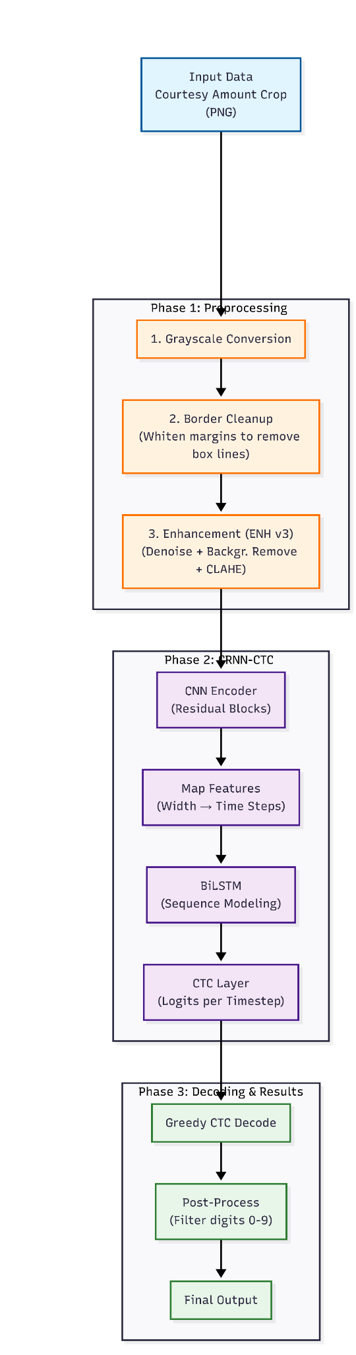Part B Architecture
In the end with many experiments for example with the transformers giving bad results may be because of the less dat and with the less time and less data and reading many resources this is the best results we got Ultimately, despite numerous experiments, such as those conducted with transformers which yielded suboptimal results—likely due to limited data—and given the constraints of time and scarce data resources, the presented results represent the best outcome achieved through extensive research.

